TI DRV8312 DEVELOPMENT TOOL

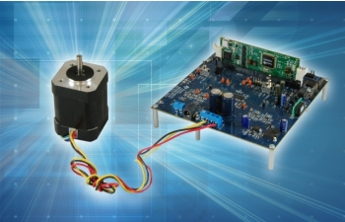

<http://www.ti.com/tool/DRV8312-69M-KIT>

User Manual : <http://www.ti.com/lit/ug/spruhj1h/spruhj1h.pdf>

MICROCONTROLLER

Piccolo TMDSCNCD28069MISO controlCARD

<http://www.ti.com/tool/TMDSCNCD28069MISO>

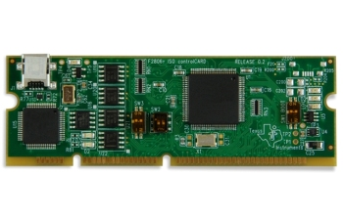

MOTOR

DT4260-24-055-04H-PT 24VDC 4000RPM 1814-0067MOTOR (telcointercon)

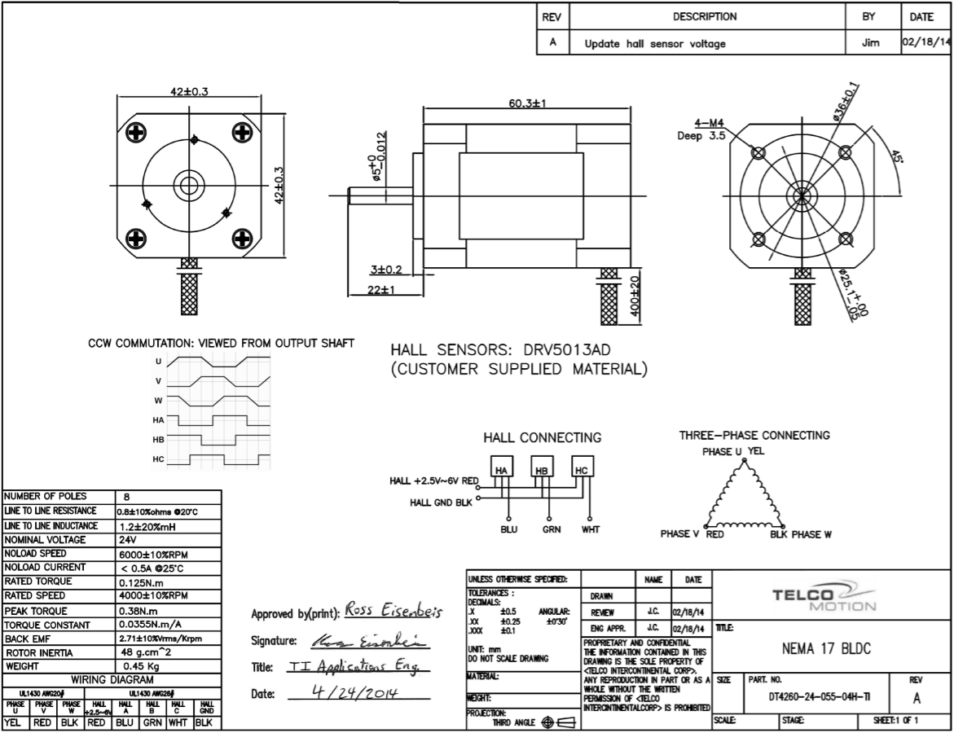

MOTOR DRIVE

DRV8312 IC

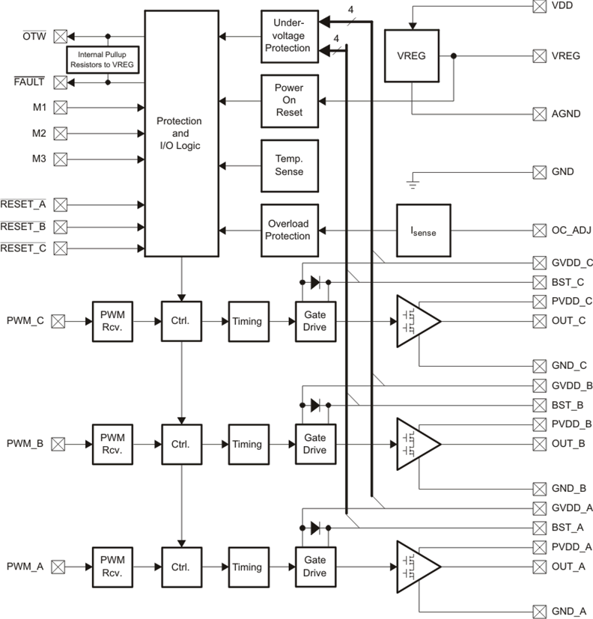

SYSTEM PRINCIPLE

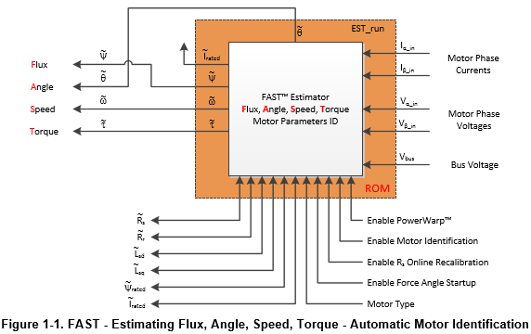

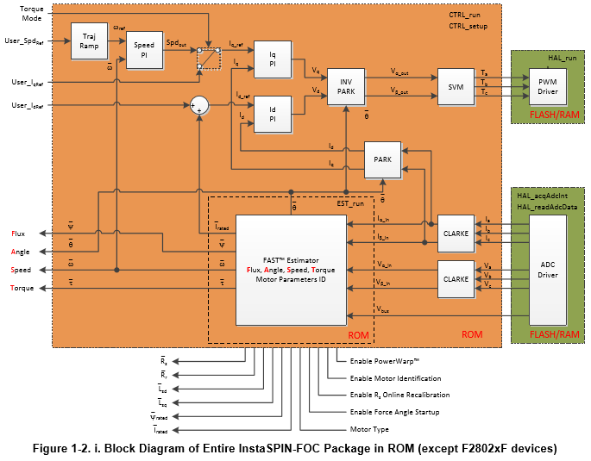

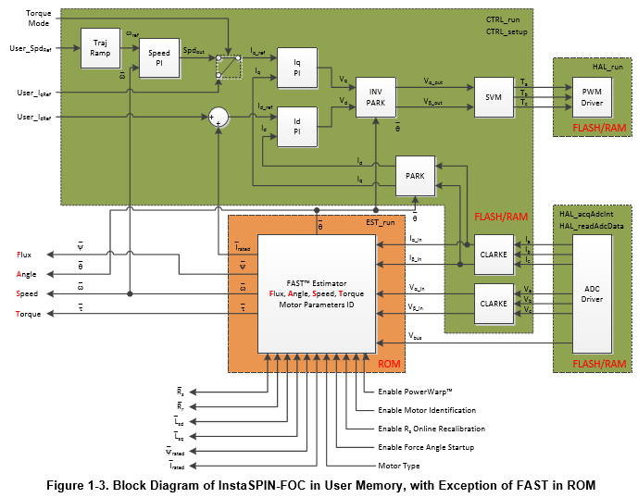

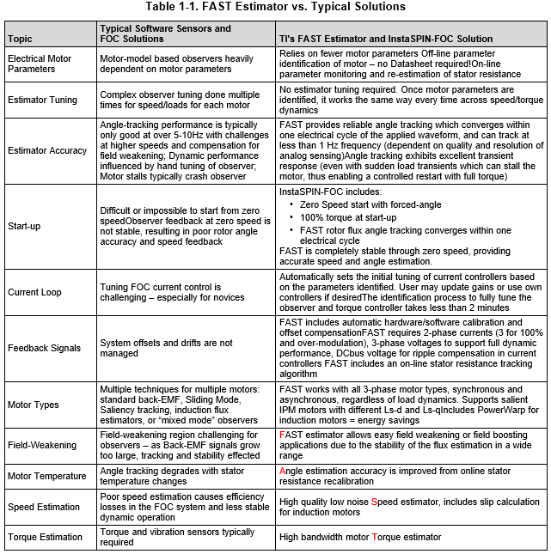

NOTES

* Beginning of the drive, it identifies the motor parameters (Lsd, Lsq, Rs, Flux, Mag. Current, Rr)
* There is a bandwidth set in the insta-motion app. With this set rotor of the motor is keeping at a specific position with stator excitations. It uses this set in spinning mode. If BW set high (60 out of 0-100) rotor is locked and unresponsive to disturbances and spinning does not start with lower rpms (0-100).